**Homework 2 Results : VBA of Wallstreet.**

**Screenshot of the result: Ticker and total Stock Value 2015**

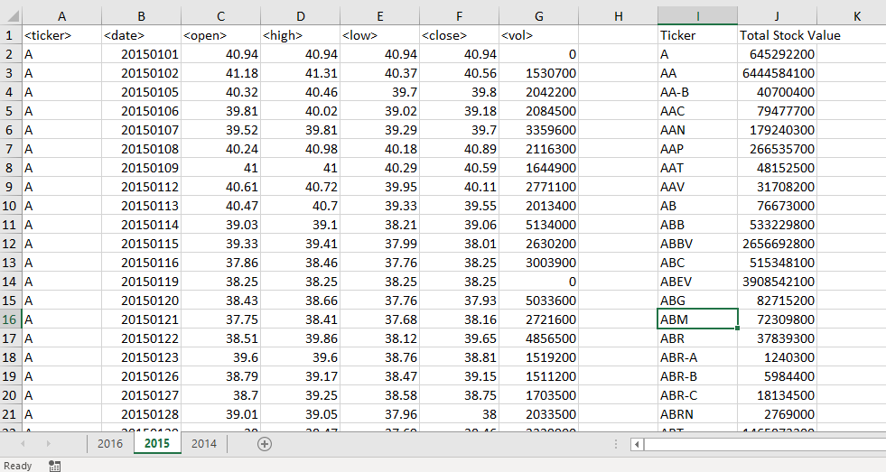

**Screenshot of the result: Ticker and total Stock Value 2016**

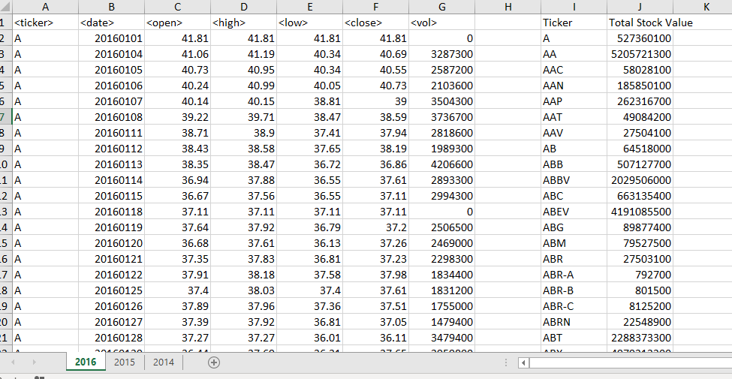

**Screenshot of the result: Ticker and total Stock Value 2014**

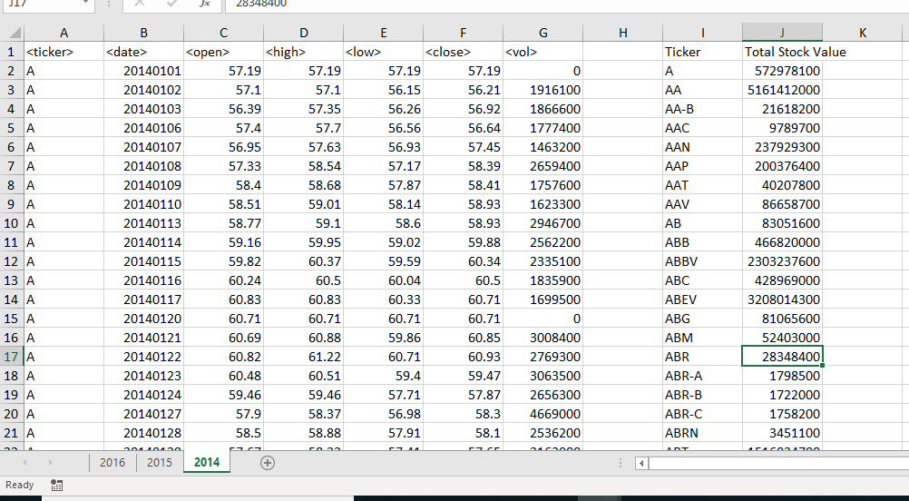

**VBA code of the above result:**

Sub TotalStockVolume():

Dim i, j As Integer

Dim total As Double

Dim ticker As String

Dim lastrow As Long

'Loop Through All Worksheets

For Each ws In Worksheets

lastrow = ws.Cells(Rows.Count, 1).End(xlUp).Row

ws.Range("I1").Value = "Ticker"

ws.Range("J1").Value = "Total Stock Value"

total = 0

j = 2

'Loop Through Each Year of Stock Data and Grab the Total Amount

For i = 2 To lastrow

If ws.Range("A" & i + 1).Value = ws.Range("A" & i).Value Then

total = total + ws.Range("G" & i).Value

Else

ticker = ws.Range("A" & i).Value

ws.Range("I" & j).Value = ticker

ws.Range("J" & j).Value = total + Range("G" & i).Value

j = j + 1

total = 0

End If

Next i

Next ws

End Sub